**WEB PROGRAMMING PROJECT REPORT**

RESTAURANT WEBSITE

Objective:

* To create a dynamic and user-friendly online restaurant website that enhances the digital presence of the restaurant, provides an intuitive interface for customers to explore the menu, make reservations, and order food online, thereby increasing customer engagement, satisfaction, and ultimately driving revenue growth.

Description:

"Welcome to Bombay Bites, your ultimate destination for authentic Indian cuisine delivered right to your doorstep! Our online restaurant project is designed to bring the vibrant flavors of Bombay (Mumbai) directly to you, no matter where you are.

At Bombay Bites, we pride ourselves on offering a diverse menu filled with classic Indian dishes bursting with spices and flavors. From savory curries to aromatic biryanis, from crispy pakoras to fluffy naans, our menu is carefully crafted to satisfy every craving and cater to various dietary preferences, including vegetarian, vegan, and gluten-free options.

Navigating our website is a breeze, allowing you to explore our extensive menu, place orders seamlessly, and track your delivery in real-time. Whether you're craving a hearty meal for a family dinner, planning a cozy night in with friends, or hosting a special event, Bombay Bites has got you covered.

In addition to our delicious food, we prioritize customer satisfaction, ensuring that every order is prepared with love and delivered with care. Our team is dedicated to providing exceptional service, ensuring that your dining experience with us is nothing short of extraordinary.

Join us on a culinary journey through the streets of Bombay, where every bite is a celebration of India's rich culinary heritage. Order from Bombay Bites today and experience the explosion of flavors that will tantalize your taste buds and leave you craving for more!"

Tools Used:

1. HTML.
2. CSS.
3. JavaScript.
4. Angular JS.
5. Php for Database Connectivity.

Project Demonstration:

1. Home Page

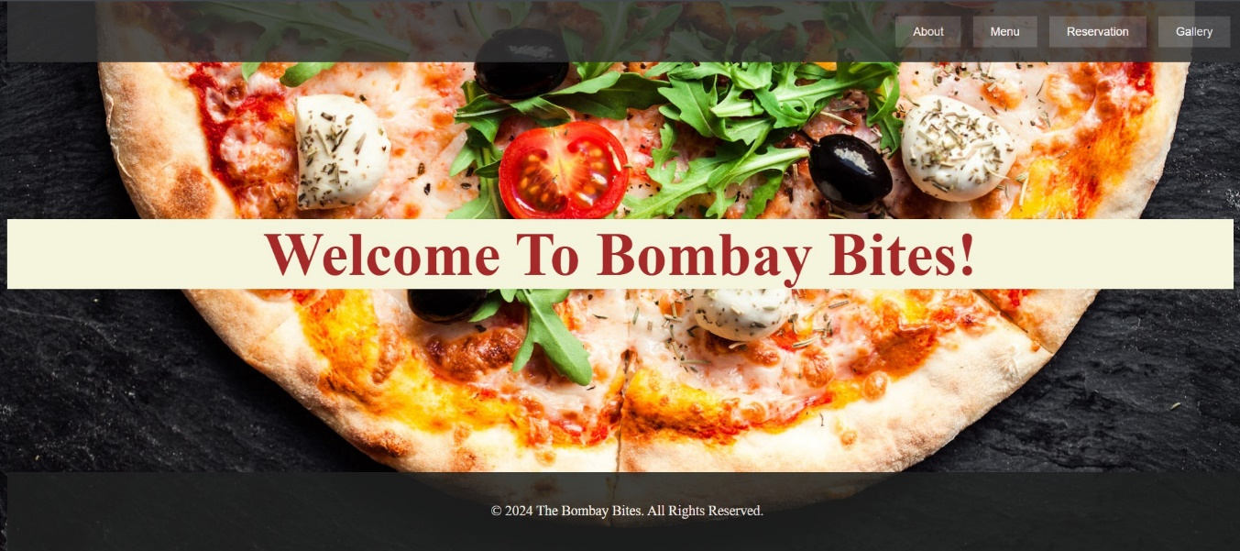

1. About Us Page

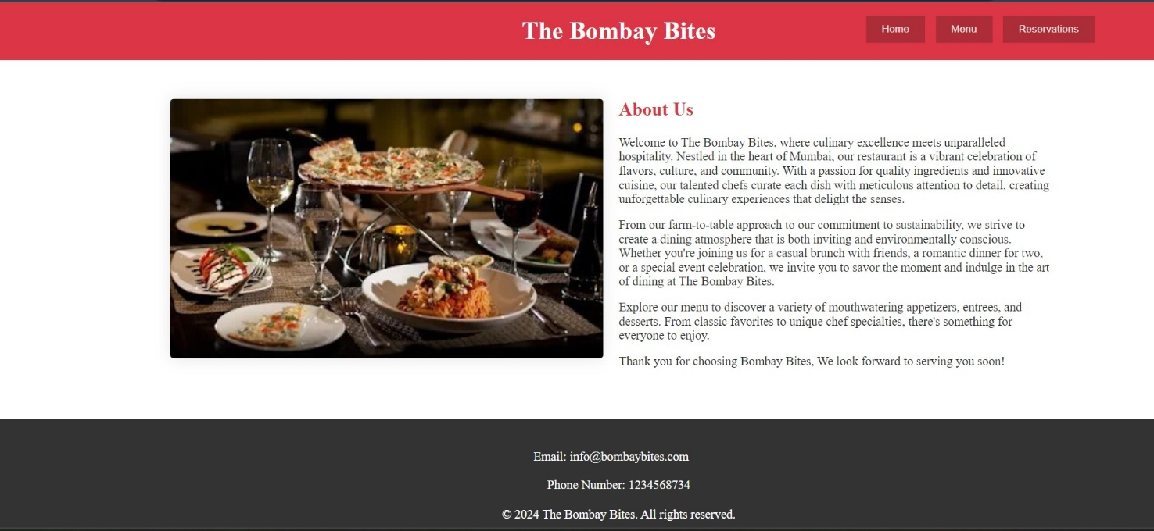

1. Menu Page

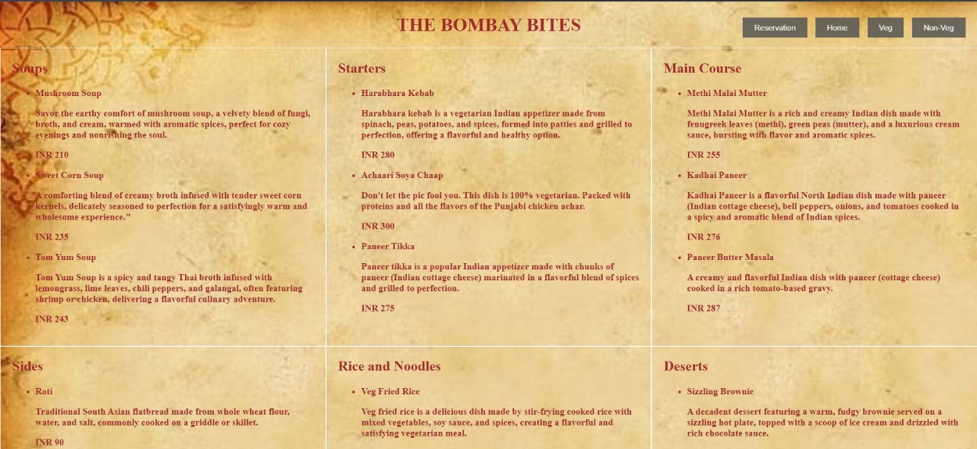

1. Only Non-Veg Menu Page

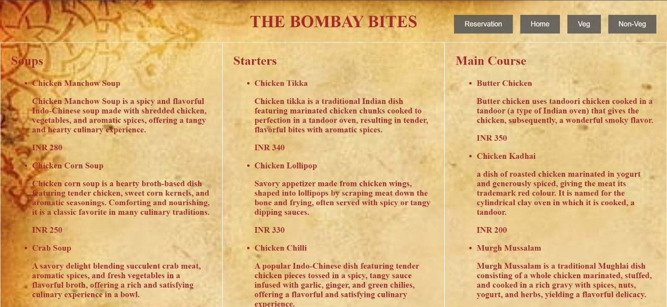

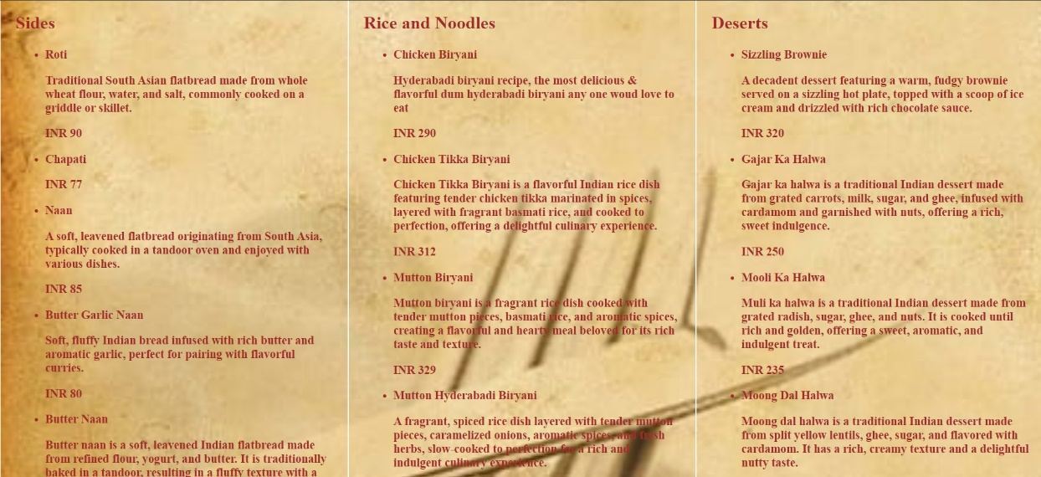

1. Only Veg Menu Page

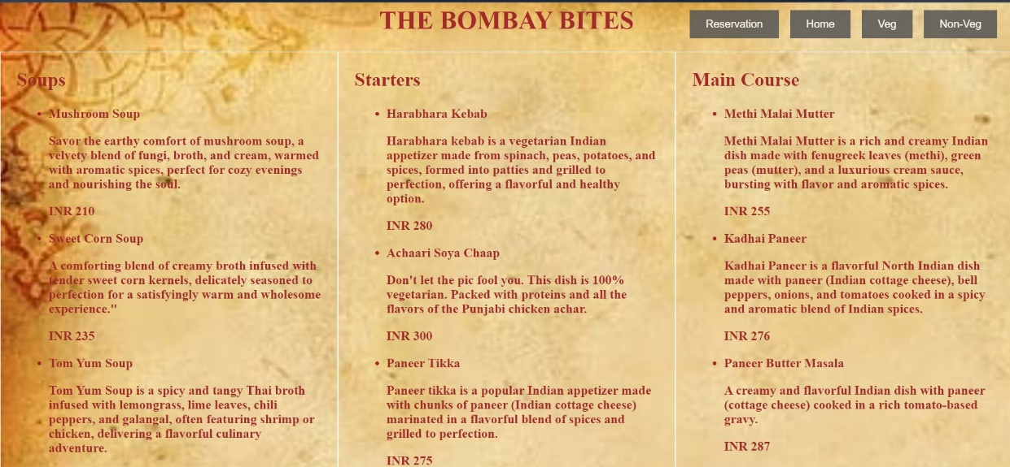

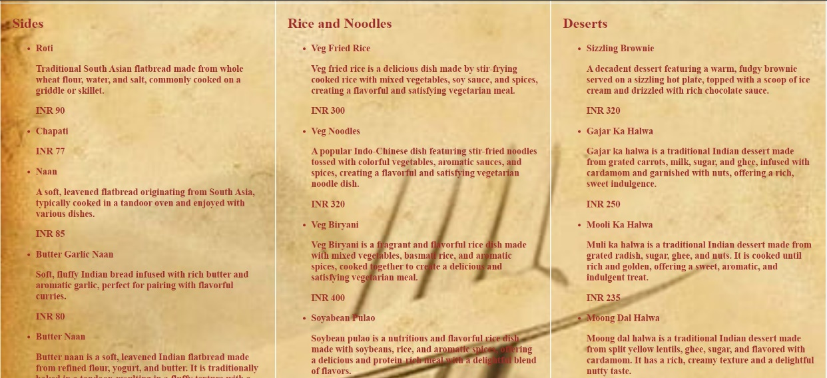

1. Reservation Form Page

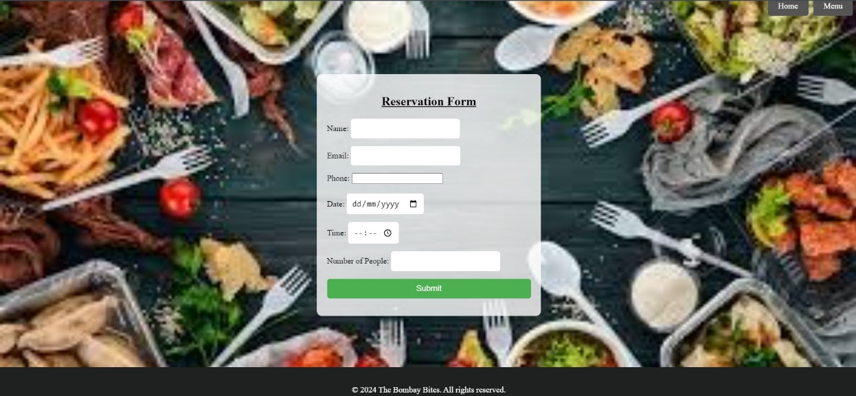

1. Gallery Page

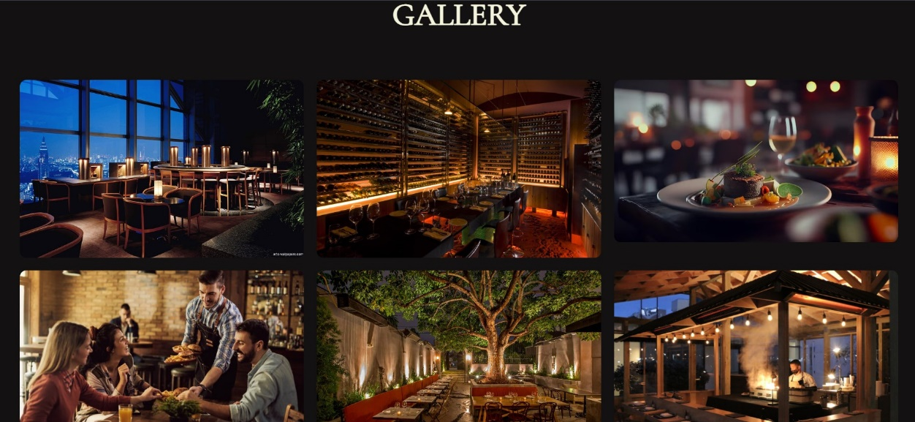

Challenges Faced:

1. Choosing suitable background images for each page was a bit tricky. We had to trial and error method to choose the background images before arriving at the last ones.
2. Positioning the navbar, respective images in the gallery section of our webpage, designing the buttons, and also choosing the respective color codes for the navbar as well as the buttons was a big task in itself.
3. Linking all web pages together and assembling the website.
4. The huge challenged faced by us was giving the website its life through JAVA SCRIPT! We had to learn so many new JS functionalities to code for each and every button.
5. Linking the database to our website.

Conclusion:

In conclusion, working on a restaurant website project as a student provided us with a hands-on learning experience that not only enhanced our technical skills but also taught us the valuable lessons in teamwork, communication, and problem-solving. This project has equipped us with practical knowledge that will undoubtedly benefit me in future endeavors in web development and beyond.

A Project By:

1. Aryan Gupte (A185).
2. Pakhi Sharma (A197).